SR UNIVERSITY
AI ASSIST CODING
LAB-2: Exploring Additional AI Coding Tools – Gemini (Colab) and Cursor AI

Lab Objectives:
Name : D.SIDDHARTHA
PinNo: 2503A51L04
Batchno:25BTCAICSB19
- To explore and evaluate the functionality of Google Gemini for AI-assisted coding within Google Colab.
- To understand and use Cursor AI for code generation, explanation, and refactoring.
- To compare outputs and usability between Gemini, GitHub Copilot, and Cursor AI.
- To perform code optimization and documentation using AI tools.
Lab Outcomes (LOs):
After completing this lab, students will be able to:
- Generate Python code using Google Gemini in Google Colab.
- Analyze the effectiveness of code explanations and suggestions by Gemini.
- Set up and use Cursor AI for AI-powered coding assistance.
- Evaluate and refactor code using Cursor AI features.
- Compare AI tool behavior and code quality across different platforms.
TASK #1:
Prompt:
Open Google Colab and use Google Gemini to generate Python code that performs sorting of a list using both the bubble sort algorithm and Python’s built-in sort() function. Compare the two implementations.
Code Generated:
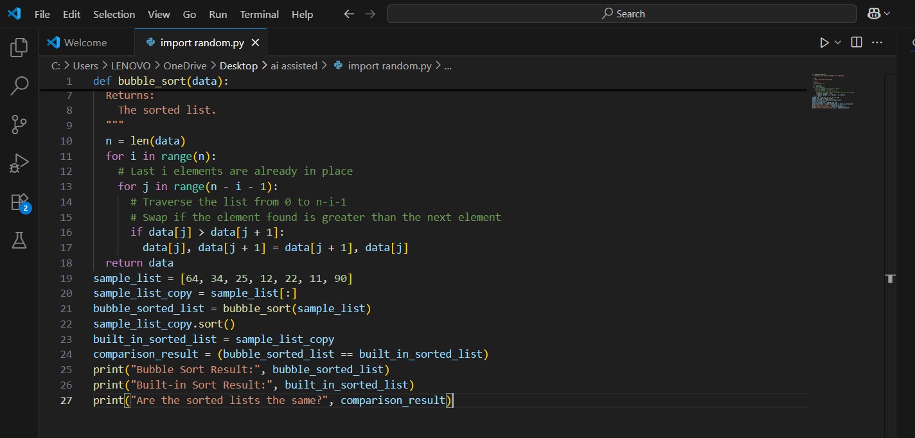

Output After executing Code:

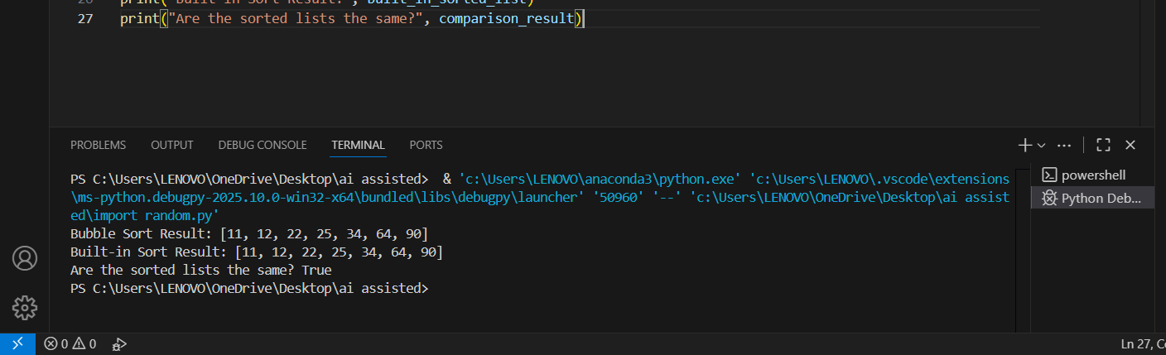
Your Observations:
- Correct Implementation of Bubble Sort:

The function bubble_sort(arr) correctly implements the bubble sort algorithm using nested loops and value swapping.
- Data Integrity Preserved:

The function uses arr.copy() to avoid modifying the original list, which is a good practice.

- Clear Comparison with Built-in Sort:
The code includes a custom sort function and compares its result with Python’s built-in sorted() function — great for validating correctness.
- Readable and Well-Structured:
The code is neatly organized into: Custom sort
Built-in sort
Example list Comparison

TASK #2:

Prompt:
In Colab, use Google Gemini to generate a Python function that takes a string and returns: The number of vowels, The number of consonants, The number of digits in the string
Code Generated:

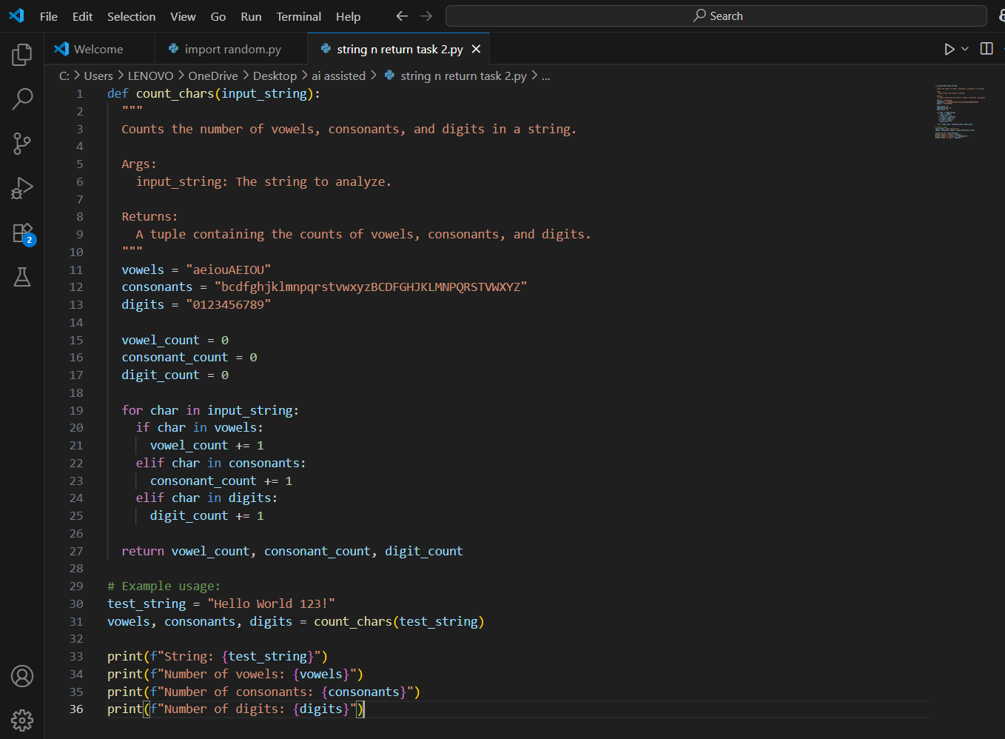

Output After executing Code:
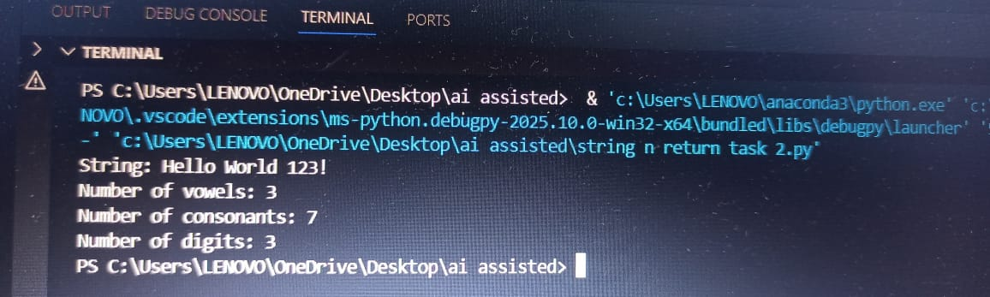

Your Observations:
Function Deflnition
- def count_lines(fllename):
A function count_lines is defined that takes a filename (e.g., "example.txt") as input.
- Try Block – Reading the File
try:
with open(filename, 'r') as file: return sum(1 for _ in file)
open(fllename, 'r'): Tries to open the file in read mode.
sum(1 for _ in flle): Counts each line using a generator expression.
It iterates through each line and adds 1 per line.
If the file is found, it returns the line count.
- Exception Handling – File Not Found
  - except FileNotFoundError:
  - If the file doesn’t exist, this block is executed.
- Created a Sample File
with open(filename, 'w') as file: file.write("Hello\n")

file.write("This is a test file\n")
The file is opened in write mode ('w') which creates a new flle.

TASK #3:

Prompt:
- Install and set up Cursor AI. Use it to generate a Python program that performs file handling:

  - Create a text file
  - Write sample text
  - Read and display the content.
Code Generated:
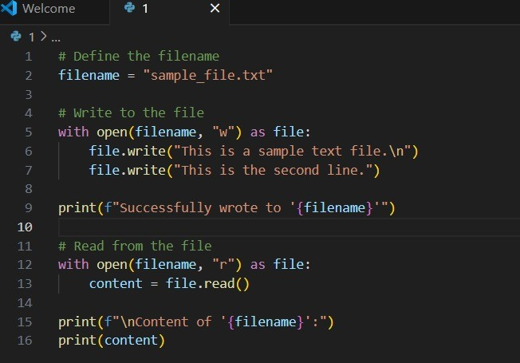
Output After executing Code:
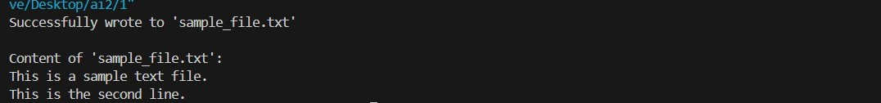
Your Observations:
1.filename = "sample_file.txt": Sets the name of the file.
- with open(filename, 'w') as file::
Opens (or creates) the file in write mode ('w'). If the file already exists, it will be overwritten.
- file.write(...): Writes 3 lines of text into the file, each ending with a newline (\n).
- print(...): Confirms that the file was created and written successfully.

TASK #4:

Prompt:
Ask Google Gemini to generate a Python program that implements a simple calculator using functions (add, subtract, multiply, divide). Then, ask Gemini to explain how the code works.
Code Generated:
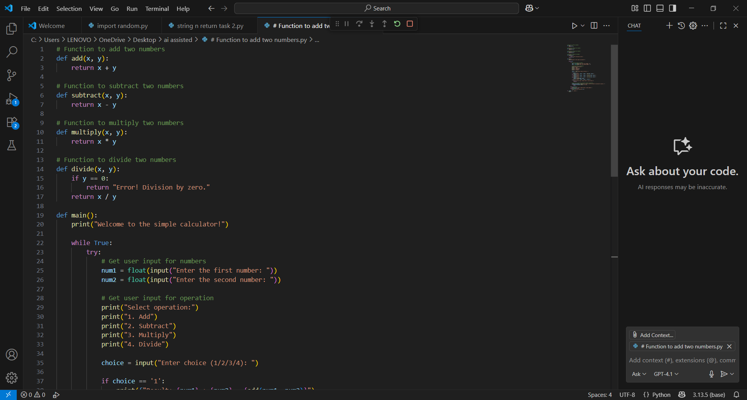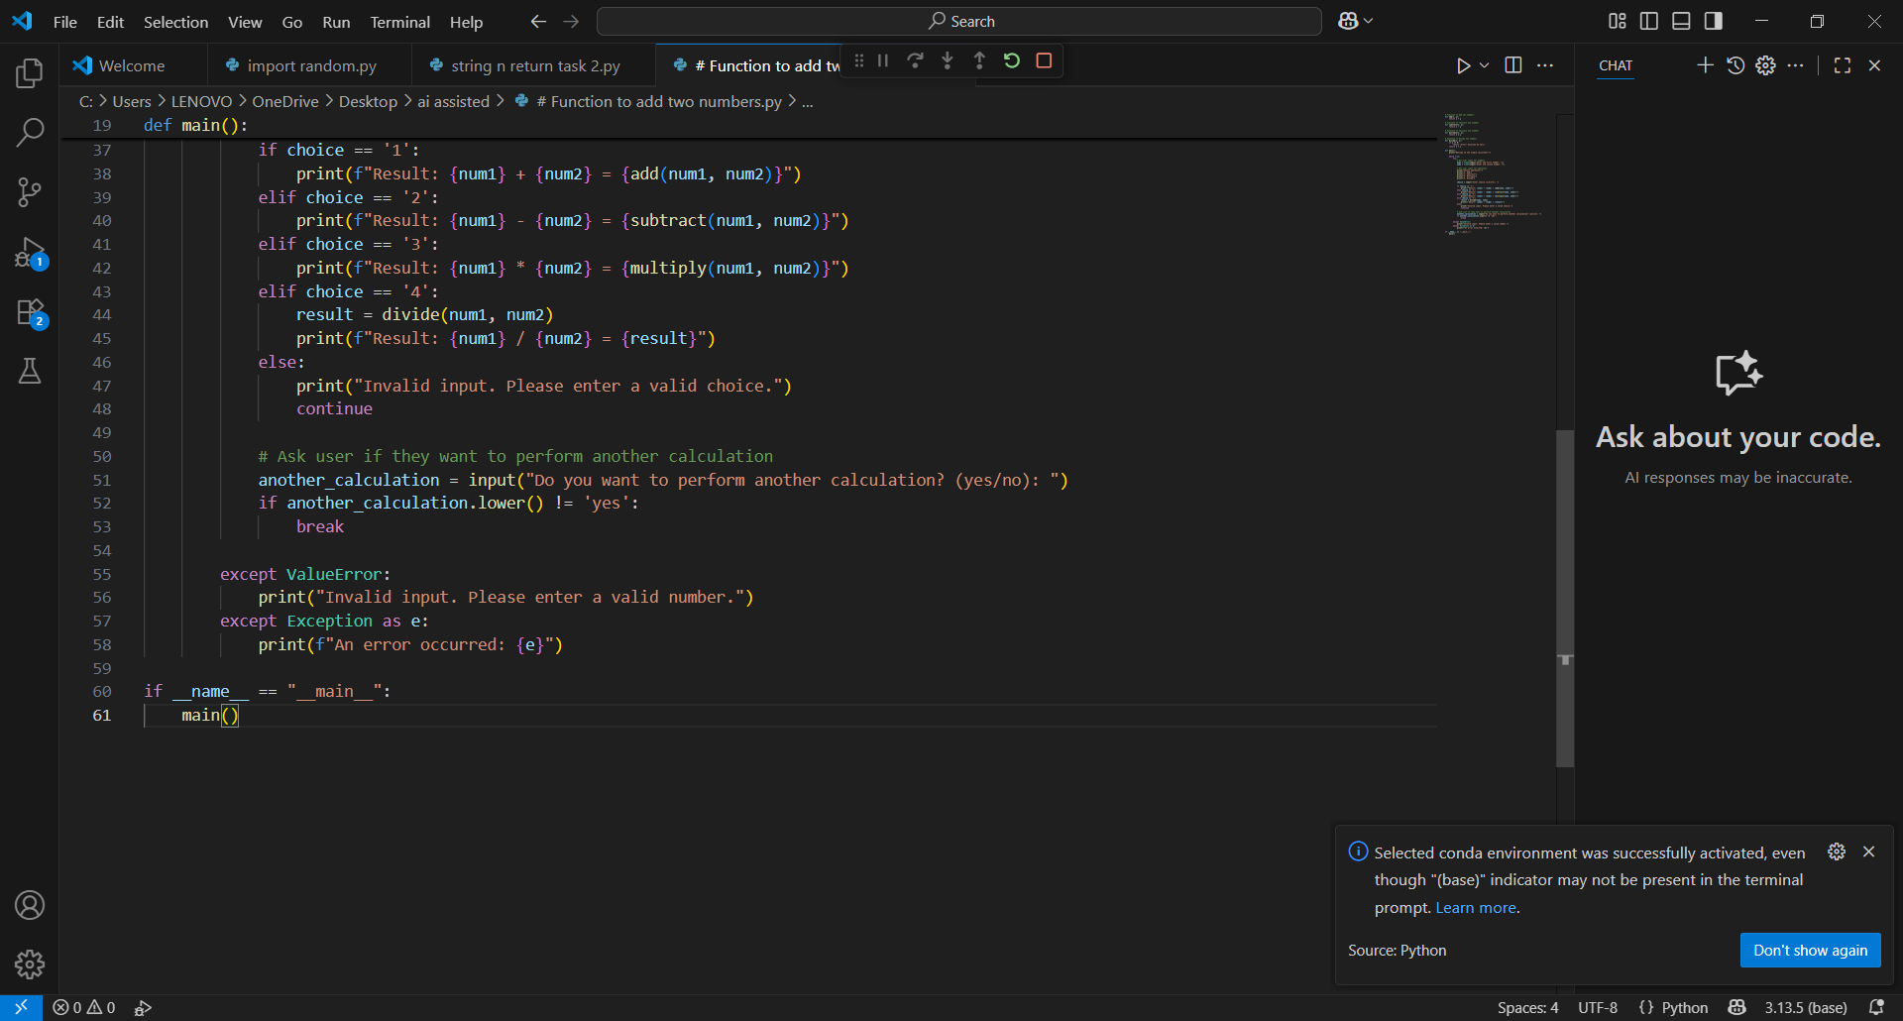

Output After executing Code:

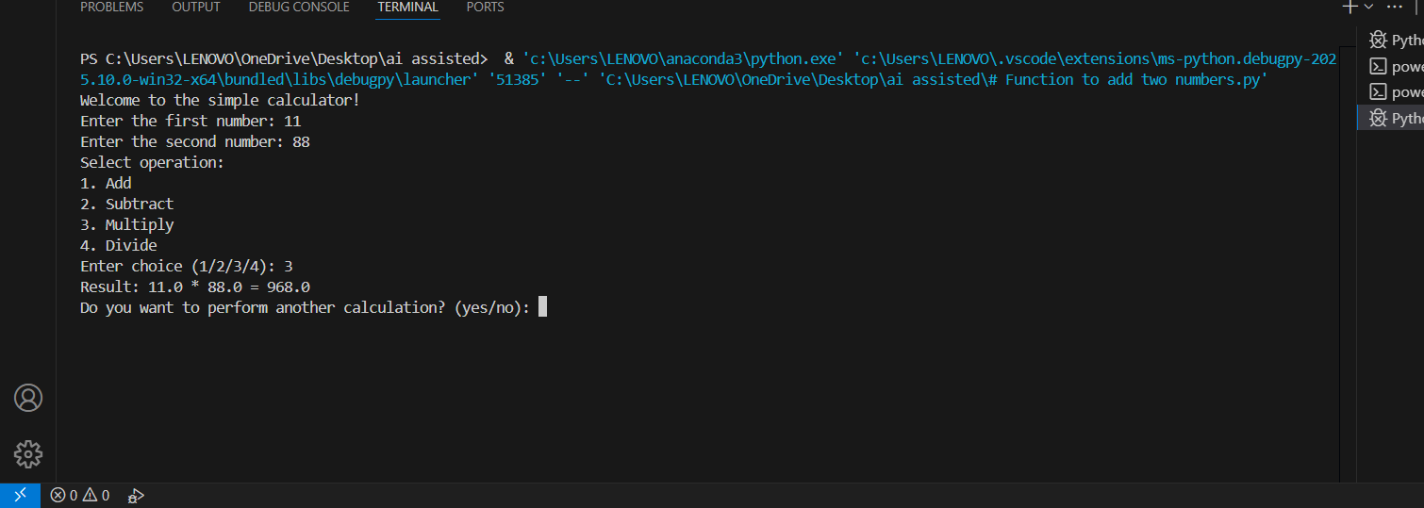
Your Observations:
- Function Deflnitions
These functions perform basic arithmetic:

->def add(x, y):
return x + y
-->def subtract(x, y):
return x - y
-->def multiply(x, y):
return x * y
-->def divide(x, y):
if y == 0:
-->return "Error: Division by zero"
return x / y

Each function takes two numbers x and y, and returns the result. The divide() function includes error handling for division by zero.
- The main() Function
This is where user interaction happens:
def main():
print("Simple Calculator") print("Select operation:") print("1. Add")
print("2. Subtract") print("3. Multiply")
print("4. Divide")
The program prints a menu of operations for the user.
choice = input("Enter choice (1/2/3/4): ")
The user selects an operation (e.g., 3 for multiply).

num1 = float(input("Enter flrst number: "))
num2 = float(input("Enter second number: "))
The user inputs two numbers, which are converted to floats for accurate calculations.
- Conditional Execution Based on Choice
if choice == '1':

print("Result:", add(num1, num2))

elif choice == '2':

print("Result:", subtract(num1, num2))

elif choice == '3':

print("Result:", multiply(num1, num2)) elif choice == '4':
print("Result:", divide(num1, num2))

else:

print("Invalid input")

Depending on the user's choice, the corresponding function is called. If the choice doesn't match 1–4, it prints "Invalid input.
- Script Entry Point
if name == "main":

main()

This ensures that the main() function runs only when the script is executed directly, not when imported.
Terminal Output : Simple Calculator Select operation:
  - Add

  - Subtract

  - Multiply

  - Divide

Enter choice (1/2/3/4): 3 enter first number: 11
Enter second number: 88
Result: 968.0
- The user selected 3(multiply).
- Entered 11 and 88.
Got the correct result: 968.0.

#task5 :

Prompt:
Use Cursor AI to create a Python program that checks if a given year is a leap year or not. Try different prompt styles and see how Cursor modifies its code suggestions.
Code Generated:
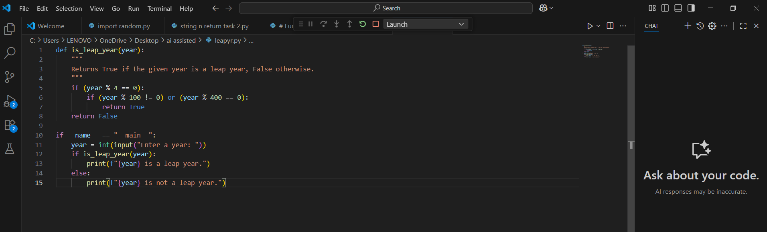
Output After executing Code:
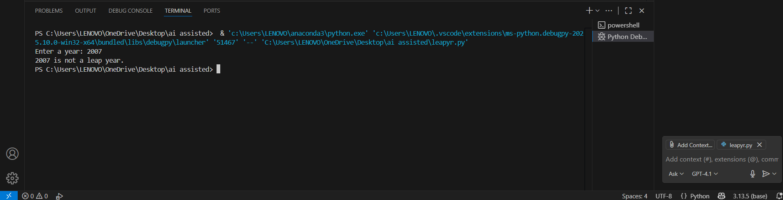
Your Observations:
- Function Deflnition
def is_leap_year(year: int) -> bool:
"""
Returns True if the given year is a leap year, False otherwise. """
return year % 4 == 0 and (year % 100 != 0 or year % 400 == 0)

Purpose: Checks leap year condition. Type hinting:
year: int → function expects an integer.
-> bool → function returns a boolean (True or False). Logic: Implements the leap year condition in one line.
- Main Execution Block
if name == " main ":
year = int(input("Enter a year: ")) if is_leap_year(year):

print(“{year} is a leap year.”)
else:
print(f"{year} is not a leap year.")

if name == " main ": Ensures this code only runs when the script is executed directly. input(...): Takes user input and converts it to an integer.
Conditional check: Calls is_leap_year(year) to check and print the appropriate message.

Output from Terminal:
Enter a year: 2007
2007 is not a leap year.
the output is correct.

